**Phase-4**

**Development Part-2**

|  |  |
| --- | --- |
| **Date** | **28-10-2023** |
| **Team ID** | **4126** |
| **Project Name** | **Personal Blog On IBM Cloud Static Web App** |

**Personal Blog On IBM Cloud Static Web App**

**Introduction**

The task at hand is to create a personal blog, which has never been easier. Whether you want to share your thoughts, experiences, or expertise with the world, having an online platform is essential. However, not all hosting solutions are created equal, and this is where IBM Cloud's Static Web App service comes into play.

In this blog, we'll embark on a journey to explore the capabilities of IBM Cloud's Static Web App service and how it can be leveraged to build and host a personal blog. IBM Cloud, with its robust infrastructure and developer-friendly tools, offers an ideal environment for web application deployment.

**Problem Statement:**

Create a personal travel blog hosted on IBM Cloud Static Web Apps. Share your travel adventures, tips, and captivating photos with the world. Use IBM Cloud Static Web Apps to easily update your blog and document your journeys. Inspire others to explore the beauty of the world and forge unforgettable memories

**Solution:**

The representation of our model is displayed below. The process of downloading the Jekyll to build our static web is shown. This involved converting our HTML content into a template files which is very easy to update.

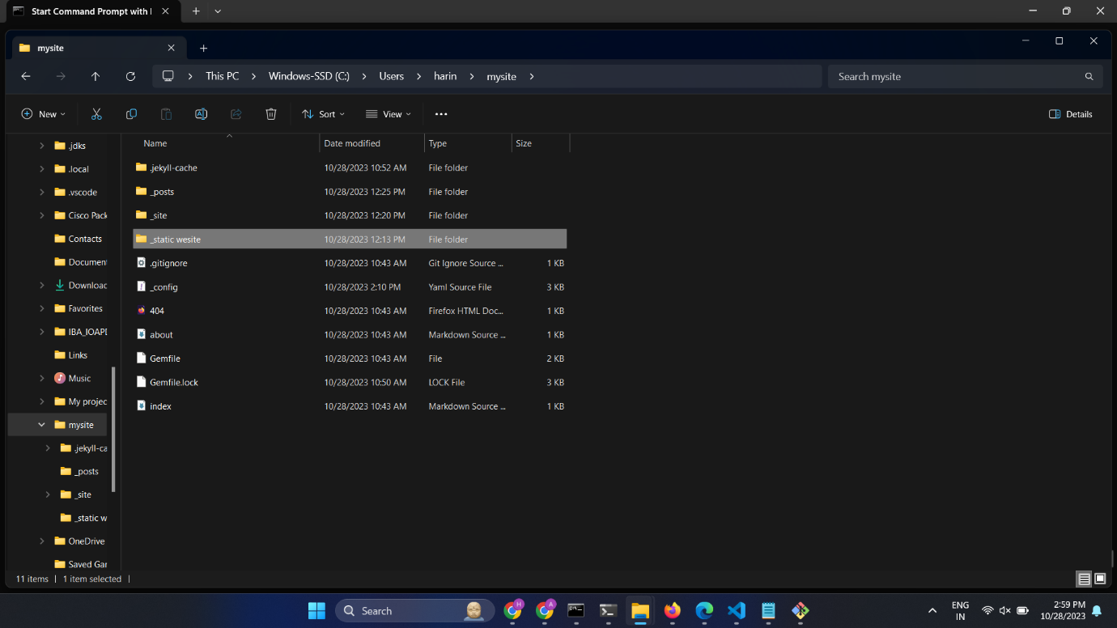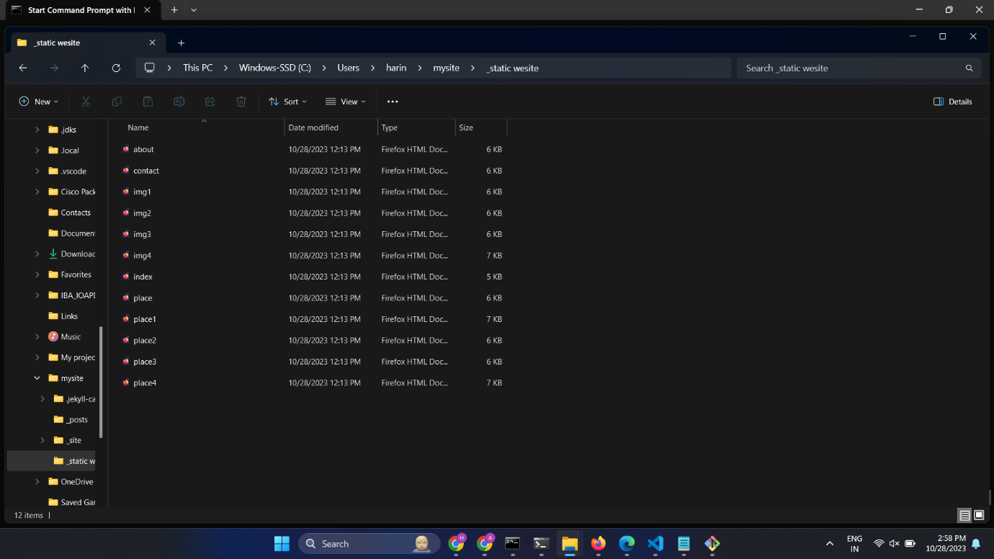

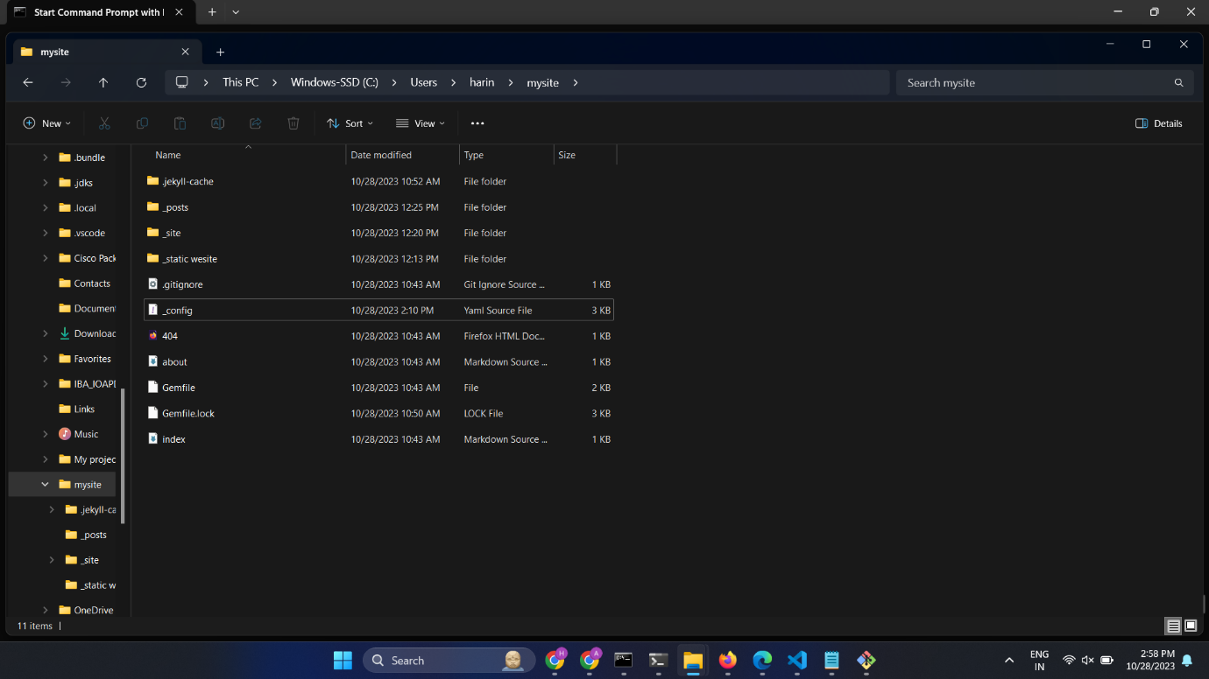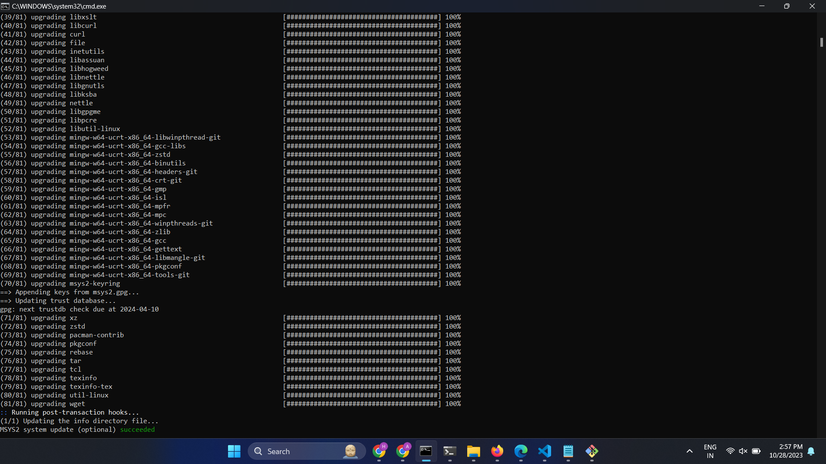

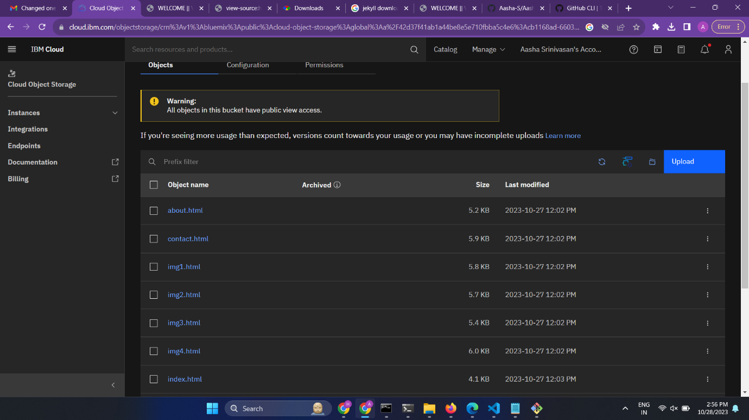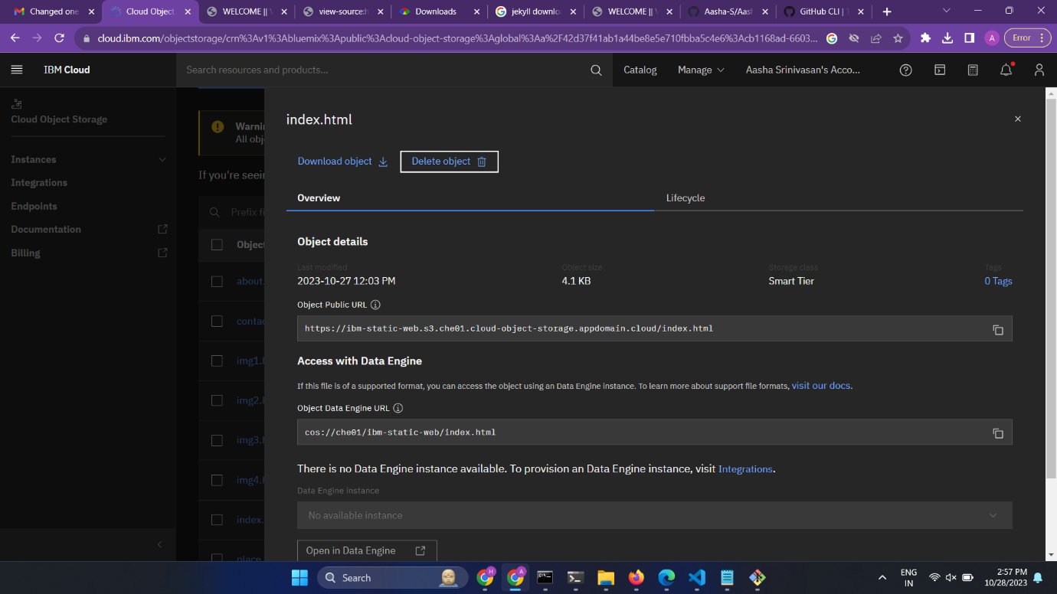

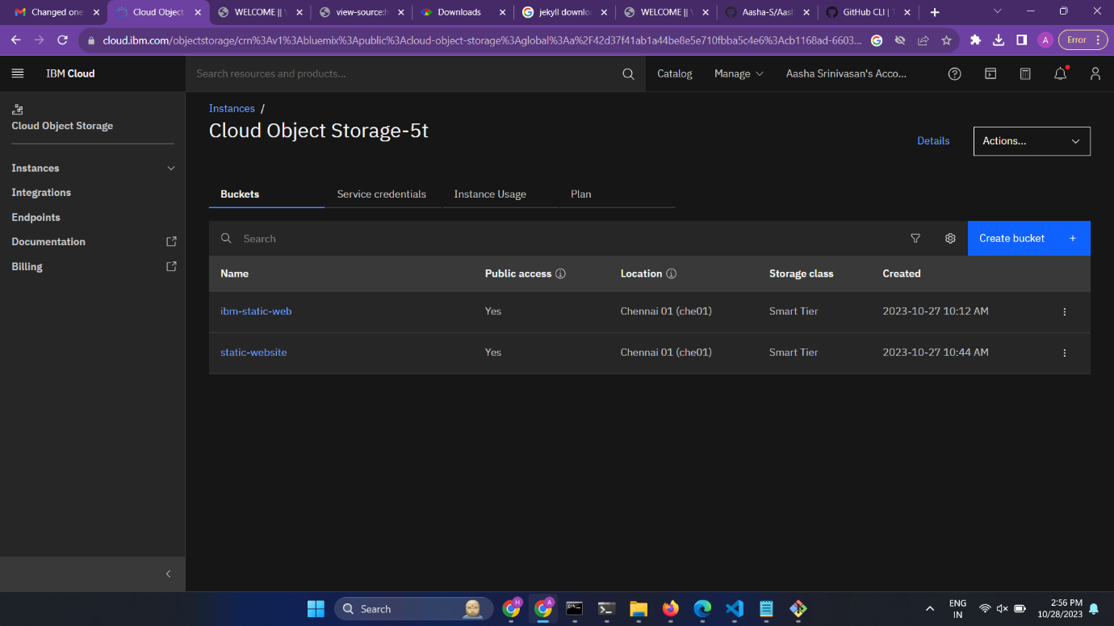

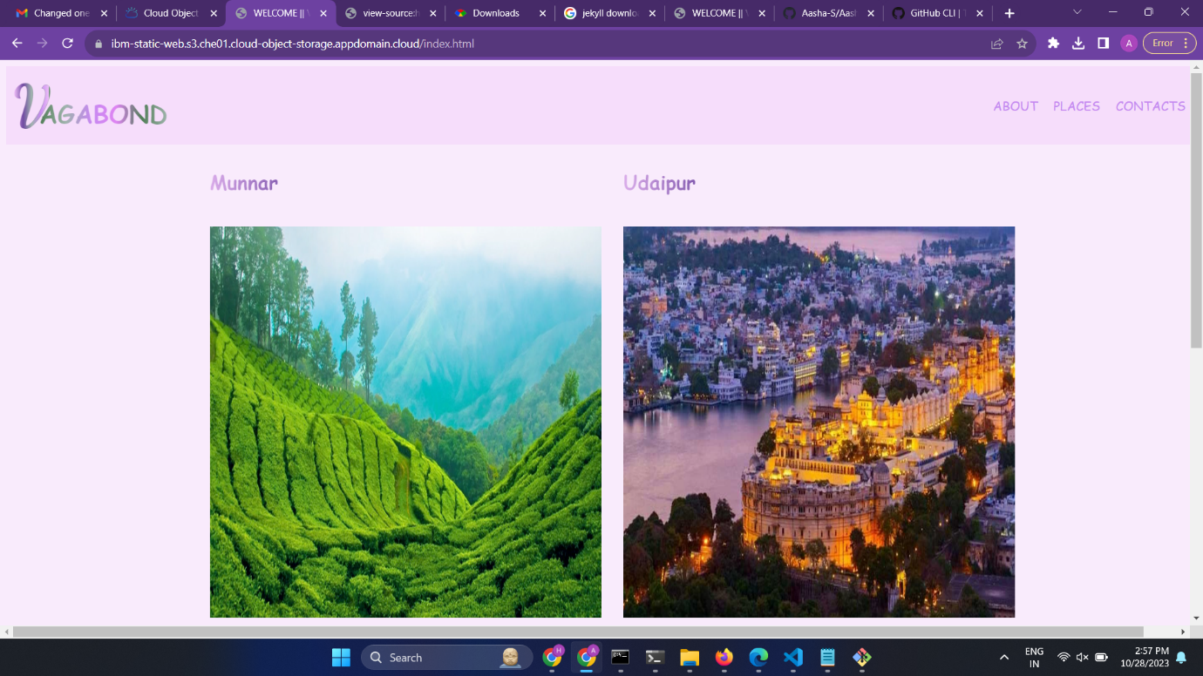

**Conclusion:**

We have completed our travel blog static web app by setting up IBM cloud static web app and deploying the website. We chose static generator like Jekyll to make as it is easy to update and manage the blog content.